Catherine's Busy Day

Meet Catherine. She’s one of those people who never seems to stop. Every morning, she wakes up at 7:00 a.m. Right now, she's stretching in bed, slowly waking herself up for the day ahead. She likes to start her day with a

bit of yoga, and today is no different. At this moment, she's on the mat, doing some stretches, her mind still calm.

Once she's done with her yoga routine, Catherine always turns to her plants. She has quite the collection at home, and she takes care of them every single day. Today, like most mornings, she's watering her plants, checking each one carefully. It's something that she enjoys, a small ritual that helps her feel connected to her home.



After that, it's time for breakfast. Usually, she has something light—tea and a little snack. Right now, she's sitting at the table, sipping her tea and enjoying the quiet.

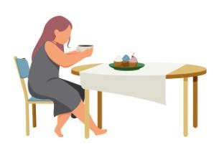



Soon, it's time to head to work. Catherine rides her bike every day because she likes the fresh air and the bit of exercise. She’s riding her bike now, cycling through the streets, her hair flowing behind her as she makes her way to

the office.

Her day doesn’t stop there, though. There’s always something to do around the house. She cleans every day, and today, she’s mopping the floor, focusing on getting everything spotless.



Evenings are a bit more relaxed for Catherine. Most nights, she reads a book or takes a bath to

unwind. Right now, she's soaking in a warm bath, feeling the stress of the day melt away. Later, she’ll probably read a few chapters of her favourite novel before heading to bed.

Eventually, she falls asleep, ready to start it all over again tomorrow. 